

*NIU Design and Construction Standards*

*Division 27 0000 – Communications*

July 2015, Rev 00

Table of Contents

**27 0000 Communications**

**27 0526 Common Work Results for Communications; Grounding / Protection 2**

•

•

•

•

•

•

•

Grounding and Protection General 3

Telecommunications Grounding Busbar 3

Bonding conductor for telecommunications 3

Two Hole Compression Lugs 4

Grounding and Bonding Installation Methods 4

Grounding and Bonding Testing 4

Building entrance protection 5

**27 0543**

•

•

•

**Underground: Ducts, Cables and Raceways for Communication Systems 5**

Direct Bury Category 3 UTP Copper Cable 5

Fiber Optic Cables in Duct System Air Blown Fiber 5

Fiber Optic Duct – Microduct systems 6

**27 0553**

•

•

•

**Identification for Communication System – Campus Labeling Standards 8**

General Guidelines, University standard is based upon following entities 8

Labels 8

Labeling inside of Data Centers and Central Office. Cabinet / Equipment Rack in Data Centers and Central Office 9

Equipment Racks, Equipment Cabinets and Equipment Enclosures, Telecommunication closets MDF / IDF 10

Horizontal Cabling Copper termination blocks/patch panels and wall plates 10

Backbone / Trunking Cabling Copper termination blocks/patch panels. Inside

Plant 11

Fiber Distribution Cabinets (FDC) and Fiber Wall enclosures (WIC) 11

Protectors for Entrance cables copper systems 12

Grounding and Bonding labeling 13

Outside Plant 13

Building Entrance 14

Communication Cables & Tracer Wires 14

Multi Cell Ducts 15

Manholes 15

Handholes and Pedestals 15

•

•

•

•

•

•

•

•

•

•

•

•

**27 1116**

•

•

**Communication Cabinets, Racks, Frames and Enclosures 16**

Communication Racks and Frames, Free Standing Equipment Racks 16

Fiber Distribution Cabinets (FDC) and Fiber Wall enclosures (WIC) 17

Communications Div 27 0000 Page 1 of 41



*NIU Design and Construction Standards*

*Division 27 0000 – Communications*

**27 1123**

•

•

**Communications Cable Management and Ladder Racks 17**

Vertical Management 17

Horizontal Wire Management 17

**27 1300**

**Communications Backbone Cabling 18**

27 1313 Backbone Communications Copper Cable Splicing and Terminations 18

•

•

Communications Copper Backbone Cabling - Category 3 UTP Copper Cable 18

Communications Copper Cable Splicing and Terminations - Category 3, 66 block termination punch down block 18

27 1323 Communications Optical Fiber Backbone 19

* Communications Optical Fiber Splicing and Terminations 19
* Communication Optical Fiber Optic Testing 20

**27 1500 Communications Horizontal Cabling– Network Wiring 21**

27 1501 Communications Horizontal Cabling Applications – General 21

•

•

Voice Communications Horizontal Cabling 21

Data Communications Horizontal Cabling 21

27 1513 Communications Copper Horizontal Cabling UTP (Unshielded Twisted Pair) 21

•

Communications Copper Horizontal Cabling Installation Methodology 22

27 1543 Communications Faceplates and Connectors 22

•

•

•

Category 6 RJ-45 Modules / Telecommunications Jacks 22

Telecommunications Faceplate 23

Horizontal Cabling, surface mounted raceway 23

**27 1600**

**Communications Connecting Cords, Devices, and Adapters 24**

27 1619 Communications Patch Cords, Station Cords, and Cross Connect Wire 24

* Communications Fiber Patch Cords, Station Cords, Cross Connect Fiber 24

**27 2100 Data Communications Network Equipment 25**

27 2129 Data Communications Switches and Hubs 25

27 2133 Data Communications Wireless Access Points (Wi-Fi) 25

•

•

General Wireless 25

Wireless Installation Methods 26

**NIU Campus Cable Standards Appendix A. 27**

**Building Codes Appendix B 37**

Communications Div 27 0000 Page 2 of 41



*NIU Design and Construction Standards*

*Division 27 0000 – Communications*

**27 0526 Common Work Results for Communications; Grounding / Protection**

**Grounding and Protection General**

A.

Communication bonding and grounding shall be in accordance with the NEC and NFPA.

B.

Horizontal cables shall be grounded in compliance with ANSI/NFPA 70 and local requirements and practices.

C.

Horizontal equipment includes cross connect frames, patch panels and racks, active telecommunication equipment and test apparatus and equipment.

D.

Telecommunications Bonding Backbone

1. Provide a Telecommunications Bonding Backbone utilizing a #6-AWG or larger bonding conductor that provides direct bonding between equipment rooms and telecommunications closets.
2. Always provide Telecommunications Bonding Backbone when using non-shielded backbone copper cable.

E. It shall be the responsibility of the contractor to ensure that the telecommunication grounding system for this facility is continuous, complete, and meets or exceeds all applicable codes and standards.

**Telecommunications Grounding Busbar**

A. All products are to be listed by UL or ETL.

B. Specifications:

1.

2.

3.

4.

Pre-drilled solid copper

Bolt hole sizing and spacing: NEMA standard Minimum thickness: 0.25"

Minimum dimensions: 4" H x 12" W, sized to accommodate all indicated and required connections

Mounting: Minimum 2" insulated standoff brackets Cover: Lettered plexi-glass

5.

6.

**Bonding conductor for telecommunications.**

A. Specifications

1. Gage: #6 AWG through 3/0 based on length
2. Insulation: Green PVC 600V insulated

Communications Div 27 0000 Page 3 of 41



*NIU Design and Construction Standards*

*Division 27 0000 – Communications*

**Two Hole Compression Lugs**

A. Specifications

1.

2.

3.

4.

5.

6.

UL listed for use up to 35 KV Temperature rated 90 degrees Celsius CSA certified to 600V

Meets J-STD-607-A

Electroplated tinned copper Two hole minimum

**Grounding and Bonding Installation Methods**

A.

. Ground all equipment as per manufacturer’s recommendations, IEEE 1100, NEC and TIA/EIA guidelines.

B.

Provide equipment grounding conductor from equipment grounding lugs to ground bar. Size conductor based on length.

C.

Provide green insulated grounding conductors from main ground busbar to one of the following, in order of preference.

1. Dedicated Telecommunications Grounding Rod or Grounding Field.
2. Building Steel
3. Electrical service ground.

D.

Provide green insulated grounding conductors from main ground busbar to each of the following.

1. Telecom Equipment Racks and Cabinets
2. Conduits and conduit sleeves
3. Cable tray

E.

Provide a green insulated grounding conductor from each end of the metallic sheath on the telephone backbone cable to the ground bar.

F.

Remove paint and or finish on all equipment racks, cable trays, etc., exposing bare metal at all locations where grounding conductor is terminated.

G.

Equipment racks that contain AC equipment may be bonded together, DC racks may also be bonded together. AC to DC rack bonding shall not occur.

**Grounding and Bonding Testing**

A. Certify system is complete and functional.

Communications Div 27 0000 Page 4 of 41



*NIU Design and Construction Standards*

*Division 27 0000 – Communications*

B. Test all cabling and connections. Perform final functional tests in presence of NIU technician.

C. Complete certified testing report.

**Building entrance protection.**

A.

All protection modules are to b UL listed.

B.

Solid state protectors are to be used.

C.

66 block style termination on the Customer Side or inside termination.

**27 0543 Underground: Ducts, Cables and Raceways for Communication Systems**

**Direct Bury Category 3 UTP Copper Cable.**

A.

Specifications

1.

2.

3.

4.

Solid Annealed, Copper Conductors

Conductor insulation is foamed polyolefin with solid skin of same material. Color coded to industry standards

Insulated conductors are twisted into pairs of varying lengths to minimize crosstalk.

Pairs are stranded into units.

Cable core is filled with a waterproofing compound and wrapped in a non- hygroscopic core tape.

Flooding compound is applied over the core and to all surfaces of the shield/armor to resist moisture and entry and corrosion.

Cable is finished with a black polyethylene jacket printed with footage markers. Conform to ANSI ICEA 7CFR-1755-890.

5.

6.

7.

8.

9.

**Fiber Optic Cables in Duct System Air Blown Fiber**

A. Single-mode Specifications

1. Meets SMF-28e standard or ULL compliant
2. Minimum performance attenuation of .5db/km at 1310nm, .5db/km at 1300nm,

.5db/km at 1500 nm.

1. Number of fibers in cable to be determined by NIU DoIT.
2. NO bend insensitive fiber is to be used.

B. Multi-mode Specifications

1. 50u/125 OM3 bend insensitive fiber.
2. Minimum performance attenuation of 3.5 db/km at 850nm, 1.2db/km at 1300nm.
3. Number of fibers in cable to be determined by NIU DoIT.

Communications Div 27 0000 Page 5 of 41



*NIU Design and Construction Standards*

*Division 27 0000 – Communications*

C. Acceptable Manufacturers

1. AFL MicroCore Blown Fiber Optic Cable

D. Installation Methods

1. All manufacturers recommended installation methods to be followed.
2. Testing of spools for acceptance
3. Testing end to end after installation, see 27 1323 for testing requirements.

**Fiber Optic Duct – Microduct system.**

A.

Specifications

1.

Microducts, depending on application, shall have either:

a)

an OD of 12mm and ID of 10mm. With an orange oversheath for multiple

ducts. Microduct colors shall be: Blue, Orange, Green, Brown, Slate, White,

Red

an OD of 8.5 and ID of 6mm.

b)

2.

3.

System may be direct buried or installed within existing duct system.

All ducts installed in the outside plant shall include a copper tracer wire, minimum 20AWG, for locate purposes.

B.

Installation Methods

1.

All empty and unused microducts are required to be capped with manufacturers approved caps, for both inside and outside plant.

All oversheaths, microducts and tracer wires shall be labeled in accordance with DoIT’s labeling standards (see section 27 0553)

Manufacturer’s installation methods shall be followed. Proper support and maintenance of bend radius shall maintained.

Microducts shall be joined together to form pathways based upon DoIT’s fiber plan. Coupling of microducts is to be determined by project.

Manufacturers recommended couplers shall be used to create contiguous fiber pathway.

Microduct organizers shall be used.

Microduct system installed in Manholes. See Attachment A.

1. Oversheath shall be run a minimum of two feet into manhole.
2. Oversheath shall be cut away and microducts shall be run around the perimeter of the manhole once.
3. Oversheath and microducts shall be installed tightly against walls and should be fastened to walls or existing cable management system. Special care shall be taken to keep ducts out of the way of people coming in and out of the manhole.
4. Microducts and fiber cables installed within shall be installed as high as possible within the manhole to avoid submersion.

Communications Div 27 0000 Page 6 of 41

2.

3.

4.

5.

6.

7.



*NIU Design and Construction Standards*

*Division 27 0000 – Communications*

e)

f)

Microducts shall be fastened together to maintain tight grouping.

Tracer wire shall be installed with ample slack and shall be mounted to a j- hook or other fastener to allow for easy access to wire from above. Tracer wire shall have enough slack to allow for wire to extend 3ft above ground level. Person accessing wire shall be able to easily reach tracer wire without having to enter the manhole. Tracer wire may need to be extended to accommodate easy access from above. Manufacturer’s recommendations for bonding together of tracer wires shall be followed.

Fiber optic cables run through microducts shall have a manufacturer provided gas tube block installed if the fiber cable and microduct next appears within a building. This only applies to cables/ducts that next appear in a building. Not manhole to manhole.

g)

8.

Microduct system installed in handholes:

a)

b)

Oversheath shall be run a minimum of two feet into handhole Oversheath shall be cut away and microducts shall be run around the perimeter of the handhole once.

Oversheath and microducts shall be installed tightly against walls. Microducts shall be fastened together to maintain tight grouping.

Tracer wire shall be installed with ample slack and shall be mounted to side of handhole with a j-hook or other fastener to allow for easy access to wire from above.

Fiber optic cables run through microducts shall have a manufacturer provided gas tube block installed if the fiber cable and microduct next appears within a building. This only applies to cables/ducts that next appear in a building. Not manhole to manhole.

c)

d)

e)

f)

9.

Building Entrance:

a)

All spaces around oversheath shall be sealed with Dura-Line recommended seal: Hyrda-Seal S-60.

All spaces around microducts shall be sealed at building entrance. See Dura- Line technical bulletin “FuturePath – Recommended Void Sealing Methods” DCEB-08008.

All cables installed through microducts shall be sealed with a gas-block connector.

Unused microducts are to be capped with manufacturers recommended seal.

b)

c)

d)

C. Microduct system spliced in direct bury situation (no protective enclosure).

1. Tracer wire shall be bonded together in accordance with manufacturer’s recommendations.
2. Shall conform to standards set out within Dura-Line Technical Bulleting DCEB- 09003 “Recommended Procedures for Splicing and Bonding Armored Future Path.PDF”

D. Acceptable Manufacturers

1. Dura-Line 7-way FuturePath 12.7mm/10mm

Communications Div 27 0000 Page 7 of 41



*NIU Design and Construction Standards*

*Division 27 0000 – Communications*

2. Dura-Line eAbf 8.5mm/6mm

**27 0553 Identification for Communication System – Campus Labeling Standards.**

**General Guidelines, University standard is based upon following entities**

A.

ANSI/TIA/EIA 606-B, Administrative Standard for Commercial Telecommunications Infrastructure

UL 969, latest edition Marking & Labeling Systems NFPA-70 NEC Current adopted edition enforced by NIU.

ANSI/IEEE C2-2007 National Electric Safety Code, latest edition

BISCI TDMM (Telecommunications Distribution Methods Manual) latest edition. BISCI OSPDRM (Outside Plant Design Reference Manual) latest edition

Where conflicts occur between codes and or specifications, the one establishing the more stringent requirements shall be followed.

Naming conventions based upon TIA/EIA 606-B (Class 3) and UL 969 for system of labeling material, including label stock, laminating adhesives and inks used by label printers

It is intended that documentation be through and provided such that there is NO ambiguity. There should be NO assumption of common knowledge on how a product “should” be installed.

B.

C.

D.

E.

F.

G.

H.

I.

**Labels**

A.

Labeling shall be provided for each of the items (at a minimum) indicated below or as directed by NIU.

1.

2.

All communication: racks, wall enclosures, cabinets, field cabinets.

All communication rooms, including all documentation of fire ratings for plywood or other materials equipment is mounted to.

Fiber termination shelves, patch panels and ports shall be labeled.

Copper building entrance terminals shall be labeled including all cables terminate inside building.

Patch cords shall be labeled.

All backbone copper and fiber cables Copper termination shelves.

Entire grounding system, including busbars and conductors.

All hand holes and manholes. The following items shall all be labeled.

3.

4.

5.

6.

7.

8.

9.

a)

b)

c)

d)

e)

All cables within manhole / hand hole, including any grounding conductors. All conduits entering system.

Cardinal directions for Manholes. Handhole or manhole number.

All ducts or microducts in system.

10. All outside plant cables.

Communications Div 27 0000 Page 8 of 41



*NIU Design and Construction Standards*

*Division 27 0000 – Communications*

11. All abandoned cables that remain shall be tagged for future use and identification.

B.

All labels shall meet the exposure (inside or outside), legibility, defacement and adhesion requirements as specified in UL 969 and herein.

C.

All labels shall be printed or generated by “mechanical device” (i.e. handheld/portable system, laserjet or inkjet printer). Handwritten labels are NOT acceptable.

D.

The size, color and contrast of all labels should be selected to ensure that the identifiers are easily read.

E.

Labels shall use black ink print on white background unless otherwise noted. Backbone and Outside Plant Fiber Optic Labels may be black ink on yellow background.

F.

Labels affixed to cables shall be flexible and allow for cable movements, bending and twisting.

**Labeling inside of Data Centers and Central Office. Cabinet / Equipment Rack in Data Centers and Central Office**

A.

Data Centers and Central office have different requirements for labeling than do building/premise areas.

All cabinets and racks in Data Centers (WL 1104 and SP 133) and Central Office (TS 200) shall have their grid coordinates clearly labeled on Top and Bottom, and front and back. Coordinates are determined by the front right of any rack or cabinet. Any cabinets with doors, shall have labels on both inside and outside of door, cabinet name clearly visible with door closed.

Racks and Cabinets shall have Rack Units clearly marked on their rails. Pre-printed or embossed labels preferred. First space (U 1) at the bottom, last space (e.g. U42, U48, U52) at top.

In Central Office all racks shall be labeled “AC equipment” or “DC equipment”.

In Data Centers, or any communications closets, DC equipment racks shall be clearly labeled as “DC equipment rack/cabinet”.

All termination blocks, in rack shall have the U space it is occupying clearly labeled on front of panel or equipment, (e.g. a piece of equipment spanning 2 U’s starting at U12 and ending in U13 (inclusive) shall have a label of “U12-U13”). This includes Fiber and Copper systems.

Any network equipment shall have a label with the following format: BBRRRR- LLNN-USU-UEU-T. Leading unused positions may be omitted.

B.

C.

D.

E.

F.

G.

1.

2.

3.

BB = Two position Building Code RRRR = 4 position Room number

LL = two position letters of grid coordinates

Communications Div 27 0000 Page 9 of 41



*NIU Design and Construction Standards*

*Division 27 0000 – Communications*

4.

5.

6.

7.

NN = two position numbers of grid coordinates

SU = three position Starting (lower) U number in rack EU = the position Ending (upper) U number in rack

T = Type of device (assigned by NIU Network Engineering Group, e.g. Switch, Router, Firewall, etc.)

Example: SP133-A9-U13-U15-S is a Network Switch in the Swen Parson Hall Machine Room 133 in a cabinet location at grid location A9, occupying the 13th through 15th U space in the rack.

8.

**Equipment Racks, Equipment Cabinets and Equipment Enclosures, Telecommunication closets MDF / IDF.**

A.

Racks and Cabinets shall have Rack Units clearly marked on their rails. Pre-printed or embossed labels preferred. First rack unit space (U 1) at the bottom, last space (e.g.

U42, U48, U52) at top.

B.

DC equipment racks shall be clearly labeled as “DC equipment rack/cabinet”.

C.

Racks shall be sequentially labeled with Building Code – Room Number Rack 1, Rack 2, etc. Label shall appear at top and bottom of rack in both front and back. (example: MB229-Rack1) is a 2 post rack in Music Building Room 229.

D.

Wall enclosures shall be clearly labeled with same standard as Racks, however with the name WIC (wall enclosure) instead of Rack. All wall enclosures shall also be labeled with the following information

1.

2.

3.

4.

5.

Type of cable terminated in WIC (e.g. Copper, Fiber). Count of cable, number of fibers or pairs of copper.

Unique cable identifier of any cable being terminated in cabinet. Type of termination, connector type and polish

Inside door of wall enclosure shall include space for documenting individual fibers/conductors.

Labeling on faceplate that includes 1st position and last position of termination. See Attachment A for labeling examples.

6.

7.

**Horizontal Cabling Copper termination blocks/patch panels and wall plates.**

**A.** Termination blocks/patch panels shall have a label per cable terminated. The label shall indicate the following information about the far end of the wire. See Attachment A for examples.

1. Room number
2. Jack letter (A through Z, if there are more than 26 jacks in a room, the format is: AA, AB, AC, AD, AE etc…)

Communications Div 27 0000 Page 10 of 41



*NIU Design and Construction Standards*

*Division 27 0000 – Communications*

1. –AP if the run is an access point.
2. In the format of RR-J-AP(optional if wire is for AP) Example: 126a-J is jack J in room 126a.

B.

Termination block shall have starting and ending U clearly labeled on front of panel.

C.

Wall plates

1. Room number
2. Jack letter (A through Z, if there are more than 26 jacks in a room, the format is: AA, AB, AC, AD, AE etc…)

Surface mounted junction boxes.

D.

1. Shall follow same labeling convention as wall plates. Labels shall be clearly visible and shall not require users to move furniture or obstructions to read labels.

**Backbone / Trunking Cabling Copper termination blocks/patch panels. Inside plant.**

A.

All 66 blocks shall be labeled to indicate pairs; 1, 25, 26 and 50. The following labeling methods are acceptable. A combination of all 3 methods is preferred.

1.

2.

3.

labels affixed to cover of 66 block. labeled on surface of 66 block

labeled on wall that 66 block is mounted to.

B.

All backbone/trunking cables shall be labeled to indicate far and near end locations. Labels shall be attached to outside jacket of trunking cable and shall be in the format of: Near end room number / number of pairs in cable, unique cable identifier, / far end room number. Example: 107E / 50pr, Cable #1 / 229. Is the first trunking cable in the building that starts in room 107E and ends in room 229, and has 50 pair of wire. See Appendix A for example.

**Fiber Distribution Cabinets (FDC) and Fiber Wall enclosures (WIC).**

A.

Identification of fiber counts and each fiber’s position within cabinet.

1. Slot for individual faceplate mounting shall be labeled left to right using Alphabetic Characters A through L (assumes 12 slot Cabinet).
2. Individual fibers within a faceplate shall be numbered so as to allow NO ambiguity on fiber count to position. See examples. Labels denoting; first, second, middle two, and last two fibers shall be labeled on the front face of each faceplate. Documentation on individual cards or attached to a drawer or cover is to be in addition to numbering on the faceplate. See Appendix A.

B.

C.

Identification of fibers near end and far end destinations.

Identification of FDC or WIC in an MDF/IDF.

Communications Div 27 0000 Page 11 of 41



*NIU Design and Construction Standards*

*Division 27 0000 – Communications*

1.

Outside cover shall have one label indicating where the enclosure is installed including:

a)

b)

c)

Building Code Room number,

Rack number or WIC number

(1) In the case of FDC in rack, the U space (starting and ending U) in rack.

2.

A second label shall be applied, (inside or outside of cover is acceptable) and shall include:

a)

b)

c)

d)

e)

Type of Fiber Count of cable

Unique cable identifier of cable (if cable is from outside plant). Relationship of cable to slots it installed to.

Example: single-mode 144, cable 3002, slots A-L.

D. Identification of fiber paths within enclosure.

1.

An electronically preprinted document shall be attached on the inside of the door of a WIC or on in the case of a FDC, on the back side of the protective door, or on the documentation shelf. This document may be a spreadsheet printed to fit the door of the enclosure. The document shall include:

a)

b)

Unique number assigned to fiber cable being terminated.

Total number of fibers terminated within cabinet and their relationship to slot numbers within cabinet.

Far end fiber termination location, including all information on cabinet, slot and fiber counts terminated.

Distance of fiber (expressed in feet for distances under 5200ft, and in miles over 5200ft).

c)

d)

2.

Documents shall be submitted electronically in Excel or PDF format as part of installation documentation.

**Protectors for Entrance cables copper systems.**

A. Outside door of copper protector shall have a label that shows; Cable number, count of the cable, and total number of pairs in the protector.

B. Termination block portion of protector shall be labeled to reflect the cable count of the cable being protected. Example: Cable 5 pairs 50 through 275 shall have labels on termination block starting at pair 50 and continuing through 275. There shall be no ambiguity as to what position on the termination block is equal to what copper

Communications Div 27 0000 Page 12 of 41



*NIU Design and Construction Standards*

*Division 27 0000 – Communications*

conductor.

This is mentioned as protectors are sometimes pre-printed with

numbering schemas, labeling needs to reflect the cable count of the entrance cable.

C. Outside jacket of copper cable coming in from outside plant shall contain a label showing the following: Current location of cable, count of cable, Next Accessible location. Example: BH 107E/ 300pr, Cable 7 / MH 109. Is a cable that comes from Manhole 109, is a 300 pair cable that is cable number 7, and is terminated in Barsema Hall room 107E.

**Grounding and Bonding labeling:**

A.

Use TMGB for the Telecommunications Main Grounding Busbar.

B.

Use TGB for the Telecommunications Grounding Busbar.

C.

Label each Telecommunications Grounding Busbar with: type of busbar, building code and room number.

Example: TMGB – AL106 is the Main busbar in Altgeld hall room 106. Example 2: TGB – AL 205 is the distribution bus bar (tied to the main) in Altgeld room 205.

D. Label both ends of all grounding conductors. Label shall show near and far end locations:

Example: TB AL 06 / TMGB AL205 is the conductor tying the distribution bus bars between rooms 106 and main bus bar in room 205 in Altgeld Hall.

Example 2: AL106-A-S / TGB AL 106 is a conductor running from the AL106-A-S switch to the bus bar in room 106.

**Outside Plant:**

A. NIU shall be provided with electronic copies of photographs clearly showing all labels mentioned below. All photographs shall be in JPG format. File name of photograph shall include the following: Type of structure being photographed (manhole, handhole, pedestal or Building Code Room number (for building entrance). Numeric designation of structure, Date. Multiple pictures of same location shall be designated by a, b, c etc.

Example 1: MH109E_09-28-2014.jpg is a picture of Manhole 109e taken on September 28th 2014.

Example 2: MH109E_09-28-2014**a**.jpg is the second picture of Manhole 109e taken on September 28th 2014.

Example 3: LH108B_11-14-2013.jpg is a picture taken of Lowden Hall room 108B building entrance on November 14th 2013.

Example 4: PD27_10-08-2012.jpg is a picture taken of Pedestal

Communications Div 27 0000 Page 13 of 41



*NIU Design and Construction Standards*

*Division 27 0000 – Communications*

**Building Entrance**

A. In buildings all ducts coming from the outside are to assigned number and labeled. The label shall include: Origin building and room number / Duct # / Destination – duct # in destination. Destination is the next point that the duct may be accessed (e.g. manhole/handhole). This includes both metal conduits / rigid ducts as well as direct buried microducts. In the case of duct going to a Manhole, the cardinal direction shall be included and labels shall match what is in the Manhole System.

Examples: The first duct in Lowden Hall room 108B that enters Manhole 109 through duct #9, shall be labeled (LH 108B / Duct 1 / MH109 - 9)

**Communication Cables & Tracer Wires**

A.

All communication cables within a manhole or hand hole shall a self-laminated tag affixed to them (recommended Panduit PST-FOBLNK).

B.

Label shall include the following information:

1. Type of cable (e.g. Fiber Optic)
2. Count of cable (e.g. number of conductors or number of fibers)
3. Cable number designation (assigned by university)
4. Current location of cable
5. Next accessible location of cable

C.

Format of label shall be the following: Current location of cable/ Type of Cable – Count #Cable number / Next Accessible location. Example: MH 122E / Copper – 400 pair #3 / HH 140, is a cable that starts in Manhole 122e, is a copper cable with 400 pair (800 conductors), that is cable #3, it next appears in handhole number 140.

D.

Tracer wires shall also be labeled with either a flag style or wrap around label. Label shall be affixed to end of wire so as to allow locating technician to easily read label without having to enter a manhole. Tracer wire label shall have the following information:

1.

2.

3.

4.

Next location that tracer wire is accessible

Duct number (when applicable) that wire is run through Current location of tracer wire

Example1: MH122E-3 / HH140

this is a tracer wire label that is in manhole

122E, where the tracer wire leaves the 3rd duct and next appears in handhole 140. Example 2: MH122E-3 / MH118-9 this is a tracer wire label that is in manhole 122E, where the tracer wire leaves the 4th duct, and next appears in Manhole 118 entering through duct 9.

5.

Communications Div 27 0000 Page 14 of 41



*NIU Design and Construction Standards*

*Division 27 0000 – Communications*

**Multi Cell Ducts**

A. All Multi Cell Ducts shall have a self-laminated tag affixed to the outside jacket / oversheath (recommended Panduit PST-FOBLNK). Label shall include the following information: Current location of duct and duct number / next accessible location of duct and duct number (if applicable).

Example: HH 140 / MH 122E-3. This is a multi-cell duct from handhole 140 next appearing in f Manhole 122E entering through the 3rd duct.

B. Individual ducts that are connected to other ducts shall also be labeled in the same format as the outside jacket / oversheath.

**Manholes**

A.

Manholes shall have their number spray painted in two locations with telecommunications orange paint on a surface that is clearly visible from someone standing outside of the manhole. It is preferred that the rim immediately below the cover/lid is used. A stencil is to be used to produce clean / crisp characters. NIU Architectural & Engineering Group cam provide Manhole numbering. New Manholes shall be assigned a number by A&E and DoIT.

B.

All penetrations that have duct work running through them shall be assigned a number. Numbers shall be hand written with a Black Paint marker or spray painted with the use of stencil and telecom orange spray paint. Labels shall be written above ducts and easily visible whenever possible. Pre-fabricated, holes in sides of manholes that do not have ductwork attached to them shall not be labeled.

C.

Cardinal directions (North, South, East and West) shall be painted on each wall of the manhole.

D.

Cable inventory sheets shall be filled out for all cables. For an example see: Appendix A.

**Handholes and Pedestals**

A. Handholes that are prefabricated and in ground, shall have their number spray painted in two locations with telecommunications orange paint on a surface that is clearly visible from someone standing outside of the handhole. A stencil is to be used to produce clean / crisp characters. NIU Architectural & Engineering Group can provide Manhole numbering. New Manholes shall be assigned a number by A&E and DoIT.

B. Pedestals shall have a label either stenciled with paint or have a printed label affixed on two clearly visible locations on the inside of the pedestal.

Communications Div 27 0000 Page 15 of 41



*NIU Design and Construction Standards*

*Division 27 0000 – Communications*

C. Pedestals shall have rugged weatherized labels on the outside that are pre-printed with the following information:

1.

2.

3.

NIU

“815-753-8100”

Pedestal number

**27 1116 Communication Cabinets, Racks, Frames and Enclosure**

**Communication Racks and Frames, Free Standing Equipment Racks**

A.

Specifications

1.

Provide two post open frame rack for mounting standard 19-inch rack width equipment.

84" height (52U Rack Units).

Printed rack space identification on all equipment rails, position 1 at bottom 52 U at top.

UL Listed for 1500 lbs load rating.

Mounting holes in top flanges for securing ladder rack.

Provide dual sided 3 x 3 vertical finger ducts on both sides of rack, front and back, for the full height of the rack frame.

Provide covered double sided horizontal finger ducts between each patch panel, or space allocate for active equipment.

Bottom of rack with holes for bolting to floor. Isolation pad to prevent rack to floor contact.

2.

3.

4.

5.

6.

7.

8.

9.

1. 12-24 threaded equipment mounting rails.
2. Black finish.
3. TIA/EIA compliant (310-D)

13. Bushings / “O” rings and other mounting hardware required to ensure that rack is isolated from floor or from other telecom equipment (e.g. stabilizing rods, ladder rack). Only path to ground should be through grounding and bonding system. This includes sleeves to ensure that floor bolts do not make direct metal to metal contact with rack.

B.

Rack Execution installation

1.

2.

3.

4.

Install racks as per manufacturer’s recommendations.

Provide rack alignment kits for all racks installed side-by-side.

Secure top of racks to structure above per the manufacturer’s instructions. Bolt racks to floor using machine bolts and expansion anchors. Ensuring grounding isolation.

Install isolation pads beneath rack to ensure isolation from floor.

Ground racks using the manufacturer’s ground lug kit for all bonding conductors. Maintain proper bend radius for all cable transitioning into and out of the racks using drop out fittings.

Communications Div 27 0000 Page 16 of 41

5.

6.

7.



*NIU Design and Construction Standards*

*Division 27 0000 – Communications*

8. Racks shall be positioned and rooms shall be designed to allow for a minimum of 3 feet of clearance in both front and back of rack. It is to be assumed that equipment may be installed / removed from both the front and back of the rack.

**Fiber Distribution Cabinets (FDC) and Fiber Wall enclosures (WIC).**

A. Specifications

1. For FDC: Rack installation compatible into universal WECO/TIA 19”/23” rack.
2. Textured black powder coat finish.
3. LGX 118 compliant mounting positions.
4. Single-mode and multi-mode fibers shall each have their own splice cabinet / enclosure. No mixing of fiber types in single cabinet or enclosure is permitted.

B. Acceptable Manufacturers

1. AFL Telecommunications Xpress Fiber Management (XFM) Rack Mount
2. AFL Telecommunications WME-02, WME-04 Wall Mount Enclosures

**27 1123 Communications Cable Management and Ladder Racks**

**Vertical Management**

A. Specifications

1.

2.

3.

4.

High capacity dual sided (front and back) vertical manager. Cable management fingers

Dual hinged door

Two managers that are dual sided required, one on each side (left and right) of rack.

Cable spindles and wire management are required inside of cable channel. Sized to handle total capacity of wires run to telecommunications room. Not to number of anticipated initial connections.

Racks that are installed side by side may share a common vertical manager as long as the common manager is sized to handle the capacity of both equipment racks.

5.

6.

7.

**Horizontal Wire Management**

A. Specifications

1. Compatible with standard 19” equipment racks.
2. Welded steel construction
3. Finished in durable powder coat.
4. Provide horizontal management suited for cable load above and below all patch bays, routers, and hubs.

Communications Div 27 0000 Page 17 of 41



*NIU Design and Construction Standards*

*Division 27 0000 – Communications*

5. Provide one horizontal wire manager (2u in height) for every 144 runs terminated within a rack. Provide (1) additional wire manager for each rack.

**27 1300 Communications Backbone Cabling**

**27 1313 Backbone Communications Copper Cable Splicing and Terminations**

A.

Specifications

1. Modular rack mounted
2. ANSI/EIA/TIA Category 6 RJ-45 Connectors
3. 48- port count

B.

Acceptable Manufacturers**:**

1. . Panduit NKPPN48P (flat)

C.

All patch panels are to be clearly labeled following university standards on labeling.

**Communications Copper Backbone Cabling - Category 3 UTP Copper Cable**

A. Specifications

1.

2.

3.

4.

5.

6.

7.

24 AWG bare copper wire insulated with thermoplastic. Three layer core construction jacketed in flame retardant PVC ANSI/TIA/EIA-568-C.2, UL 444 and C22.2 No. 214-02 Plenum-NFPA 262, CMP

ANSI/TIA/EIA-568-B.2 Category 3 Backbone Cable

6.6 nF/100 m nom. Mutual capacitance

9.4 ohms/100 M Max, DC resistance

**Communications Copper Cable Splicing and Terminations - Category 3, 66 block termination punch down block.**

A. Specifications

1.

2.

3.

4.

5.

50 pair capacity

66 block kit

Special Red Service Markers shall be provided for all alarm circuits. Category 5e

Terminates 22-26 AWG (0.81-.41mm) solid insulated or 18-19 AWG (1.02- 0.91mm) solid stripped cable

Clear snap on covers shall be provided for each block. Adhesive backed, lined labels for snap on cover.

Block

6.

7.

8.

a)

b)

c)

Height 254mm (10 in) Width 86.4mm (3.4 in) Depth 30.5mm (1.2 in)

Communications Div 27 0000 Page 18 of 41



*NIU Design and Construction Standards*

*Division 27 0000 – Communications*

**27 1323 Communications Optical Fiber Backbone**

A.

Microduct systems for use with air blown fiber shall be the standard for indoor installations.

B.

C.

Plenum rated jackets shall be used.

Installation Methods

1. Install all cabling and secure in a high state of dress utilizing wire management system.
2. Use only hook and loop (Velcro) type straps to secure and dress fiber cables.

**Communications Optical Fiber Splicing and Terminations**

A.

University uses LC- UPC connectors for all single-mode fiber. LC for all multi- mode fiber.

B.

Multi-mode fiber shall be Laser Optimized OM3, unless otherwise specified.

C.

LC duplex adaptors for both single-mode and multi-mode cable.

D.

Ferrell color

1. Single-mode UPC connector Blue
2. Single-mode APC connector Green
3. Multi-mode 50/125 OM3 Laser Optimized Aqua
4. Multi-mode 62.5/125 Beige

E.

Based on LGX 118 footprint

F.

Utilize cassette based, patch and splice enclosures. Both patch face plates and splice enclosures are to be housed in individual cassette, 24 fibers per cassette. Lower counts of fibers per cassette (e.g. 12) may be used only with permission of DoIT.

G.

All terminations shall factory pre-terminated fusion style connectors. No mechanical connectors are allowed.

H.

Secure fiber jacket in a minimum of two locations.

I.

Install minimum two meters of unjacketed fiber strands coiled on the enclosure routing guides.

J.

Acceptable Manufacturers - face plates.

Communications Div 27 0000 Page 19 of 41



*NIU Design and Construction Standards*

*Division 27 0000 – Communications*

1. AFL Global FM000939 multi-mode adapter plate. Part of LightLink Poli-Mod system.
2. AFL Global FM000936 single-mode adapter plate. Part of LightLink Poli- Mod system.

K. Air blown fiber shall use Fan out kits and Router kits to maintain binding groups within enclosures. All fibers shall be routed through Fan out or router kits (both terminated an unterminated).

L. Unterminated fiber within enclosures shall be of sufficient length to allow for future termination. A minimum of 5 meters within enclosures.

M. Fibers shall be laid out into FDC’s and WIC’s in accordance to NIU’s standard. See Attachment A for examples.

**Communication Optical Fiber Optic Testing**

A.

All fiber optic cables shall be tested with the following tests and criteria.

1.

Tests shall be run on each fiber, no “loop back” testing is allowed.

2.

Continuity test to ensure no “frogging” of fibers have occurred. Verification may be done with VFL for distances under 5km.

All fiber connections, including bulkheads and patch cables shall be cleaned and inspected to ensure that cables are free from defect or debris. Testing shall be done using a microscope in compliance with IEC 61300-3-35. Testers shall certify that the each fiber was cleaned and inspected prior to each OLT (Optical Loss Test) and OTDR tests.

OLT, documenting the dB loss of fiber. Note: testing requires the use of a power source and separate power meter as no looping of fiber is allowed. OTDR (Optical Time-Domain Reflectometer) tests in both directions with the following criteria

3.

4.

5.

a)

b)

c)

d)

Test to be run a minimum of 1 minute

Tests shall be taken at 1310nm and 1550nm for single-mode fiber. Tests shall be taken at 850nm and 1300nm for multi-mode fiber.

Launch and receive cables of a minimum distance of 100 meters shall be used for all OTDR testing.

All events shall be shown on test results. No minimum threshold to ignore events shall be allowed.

Pulse widths may be auto selected by test equipment. Special care shall be taken to ensure that pulse widths fall within manufacturer’s recommendations for distance of fiber being tested.

e)

f)

6.

A summary of all fiber testing and installation shall be provided by filling out 27_13_23_26_Fiber_Testing_Cut_Sheet.xls

Communications Div 27 0000 Page 20 of 41



*NIU Design and Construction Standards*

*Division 27 0000 – Communications*

7. OTDR test results shall be provided in both manufacturers original test gear format as well as in a PDF or Word Document format. Electronic copies are required.

**27 1500 Communications Horizontal Cabling – Network Wiring**

**27 1501 Communications Horizontal Cabling Applications – General**

A.

University has standardized on a universal KeyStone solution. The Panduit NetKey system is used. Termination of wire is to be individual modules on each end. No proprietary manufacturer’s termination is to be used.

B.

Each network channel requires one network cable per telecommunications jack. No splitting of wires is allowed.

C.

All communication wires between end points and the nearest communication closet shall be category 6 compliant, regardless if wire is to be used for network or telephone connections.

D.

Each telecommunications outlet that requires both network and telephone connections, shall consist of TWO Category 6 wires, 1 for network and 1 for telephone and or future network connections.

E.

Wiring shall be installed by certified Panduit NetKey installers.

F.

All channels must be warrantied. All wires must pass category 6 standards and must be tested with Panduit approved test gear.

G.

Testing documentation is to be provided to NIU in an electronic format.

**Voice Communications Horizontal Cabling**

A. Both voice and data will utilize Category 6 wiring for Horizontal cabling. See section 27 15 13

**Data Communications Horizontal Cabling**

A. Both voice and data will utilize Category 6 wiring for Horizontal cabling. See section 27 15 13

**27 1513 Communications Copper Horizontal Cabling UTP (Unshielded Twisted Pair)**

A. Specifications

1. All cable must be NEC type OFNP or NEC type CMP unless otherwise noted.

Communications Div 27 0000 Page 21 of 41



*NIU Design and Construction Standards*

*Division 27 0000 – Communications*

2.

3.

4.

5.

6.

7.

NEC CMP Rated

4 pair, 23 AWG, solid bare annealed copper Flame Retardant semi-rigid PVC insulation Longitudinal rip cord

ANSI/EIA/TIA Category 6 compliant Color of cable jacket:

1. Network Communication cable in general is blue when cable is run above ceilings or in conduit/raceway. Different colors (primarily white or black) cable may be required if cable is to be exposed and visible. Aesthetics of space may dictate a different color of wire jacket and is to be approved by NIU DoIT.
2. Security door access – orange
3. Security Camera system – orange

All cable will be terminated onto a module / female RJ-45. No wire will be terminated directly to a male RJ-45 plug.

Acceptable Manufacturers

1. Panduit PUP6004BU-UY/CMP-0042PDN-7RB-06 TX6000 Category 6 UTP

cable.

8.

9.

**Communications Copper Horizontal Cabling installation methodology.**

A. General

1.

2.

3.

Follow all ANSI/EIA/TIA installation guidelines. Follow all cable solution provider installation guidelines.

Install all cabling and secure utilizing wire management and hook and loop (Velcro) straps. No plastic cable ties shall be used to secure any cabling.

Install cable management to support and train cables within space as required to meet bend radius and support requirements.

Do not exceed 90 meters in length for any Category 6 cables. Maintain wire twists to within .5 inches of termination.

Remove no more than 1.0 inches of cable jacket.

4.

5.

6.

7.

**27 1543 Communications Faceplates and Connectors**

**Category 6 RJ-45 Modules / Telecommunications Jacks**

A. Specifications

1.

2.

3.

4.

5.

6.

7.

Category 6 module featuring 110-termination technology Keystone compliant form factor.

Backwards compatible to Category 3 ANSI/EIA/TIA 568-B.2-1 Category 6 compliant. Sweep tested through 250 MHz

UL 94VO Polycarbonate construction

Accepts 24 through 22 AWG solid copper conductors

Communications Div 27 0000 Page 22 of 41



*NIU Design and Construction Standards*

*Division 27 0000 – Communications*

1. Standard jack color is Off White (Panduit Color Code IW), unless aesthetics of space dictate otherwise.
2. University uses the TIA-568B wiring schema.

B. Acceptable Manufacturers

1. Panduit NK688MIW

**Telecommunications Faceplate**

A.

Specifications

1.

2.

3.

4.

5.

6.

7.

Single gang plate 4 ports capacity

UL 1863 Compliant

Faceplate finish and style shall match electrical faceplates. Clear label cover.

All unused positions shall have blanking plates installed.

For wall mounted faceplates in residence halls and areas that are high usage for public access (e.g. computer labs, cafés, hoteling spaces, libraries) angled faceplates are required.

All installed modules will be oriented to prevent dust and debris from settling on pins and for ease of use. Pins will be up for flat faceplates. Pins will be down (to allow for easy access to patch cable clip) for any angled faceplate. See Attachment A for examples.

8.

B.

Acceptable Manufacturers

1. Panduit NK4FIWY (straight)
2. Panduit NK4VSFIWY (angled)

**Horizontal cabling, surface mounted raceway.**

A.

Specifications

1. Off White (IW) in color (unless aesthetics of space dictate otherwise).
2. Rigid PVC
3. UL 94V-0; FT4

B.

Installation Methods

1. Raceway must be mounted to surface with screw or fastener. Use of adhesive backing only is not allowed. Minimum of 3 fastener per 8 feet of track.

C.

Acceptable Manufacturers

1. Panduit LD-5

Communications Div 27 0000 Page 23 of 41



*NIU Design and Construction Standards*

*Division 27 0000 – Communications*

2. Panduit T-70

**27 1600 Communications Connecting Cords, Devices and Adapters.**

**27 1619 Communications Copper Patch Cords, Station Cords and Cross Connect Wire.**

A.

Specifications

1.

2.

3.

4.

5.

ANSI/EIA/TIA Category 6

4 pair RJ 45

Strain relief in boot Tested to 250 MHz

All cables are to be factory assembled, no field fabrication or field termination allowed.

Jacket color of patch cables and cross connect wires as follows:

6.

a)

b)

Blue – Data / VoIP connection.

Orange – Door Access, Security, camera systems and Public Announcement systems.

Green – Lights out and management (data centers and central office only). Purple – Out of band device management. Typically only one of these cables per network switch.

White/Red jumper wire for any alarm system that utilizes the telephone system. Examples: Category 3 ‘dry loops” to police department for security alarms or fire alarm systems.

c)

d)

e)

B.

Acceptable Manufacturers

1. Panduit NK6PC***Y NetKey Patch Cable.

**Communications Fiber Patch Cords, Station Cords, Cross Connect Fiber.**

A.

Fiber shall be installed in a method that maintains minimum bend radius and allows for proper strain relief of connectors.

B.

Fibers shall be of appropriate length as to prevent slack loops in fiber management systems.

C.

All cables are to be factory assembled, no field fabrication or field termination allowed.

D.

All cables shall be factory tested with test results clearly labeled in packaging.

Communications Div 27 0000 Page 24 of 41



*NIU Design and Construction Standards*

*Division 27 0000 – Communications*

**27 2100 Data Communications Network Equipment.**

**27 2129 Data Communications Switches and Hubs**

A.

Information in this section is for informational purposes only as it relates to power and space planning. Any equipment provisioning or procurement decisions are to be made by NIU’s Division of Information Technology’s Network Engineering Team.

B.

In general NIU uses the Cisco family of products for in building Access Switches.

C.

Switch family / model is determined by the total number of active connections. Not by the total number of wires installed in the switch closet.

1.

75 or more – Cisco Catalyst 4500 family of switches.

1. Dual power supplies sufficient to run all ports at maximum POE output.
2. Each 4500 power supply (two power supplies per 4500 chassis) shall have a dedicated electrical circuit. There shall be a minimum of two circuits per 4500 chassis.

Less than 75 and more than 40 connections – Two Cisco 2900 switches stacked. 40 or less connections – One Cisco 2900 switch.

2.

3.

D.

Power receptacles shall utilize a twist lock configuration. (e.g. NEMA L5-20R / L6- 20R).

E.

Sufficient environmental systems shall be provided to provide manufacturers recommended operating temperature and moisture levels. For planning it is assumed that network switch gear will be working at 100% power output.

F.

American Society of Heating, Refrigeration and Air-Conditioning Engineers (ASHRAE) guidelines Technical Committee 9.9 are followed. Temperatures listed are measured at the equipment’s air intake.

1. Low-end temp: 64.4 degrees Fahrenheit
2. High-end temp: 80.6 degrees Fahrenheit
3. Low-end moisture 40% relative humidity and 41.9 degrees Fahrenheit dew point
4. High-end moisture 60% relative humidity and 59 degrees Fahrenheit dew point.

**27 2133 Data Communications Wireless Access Points (Wi-Fi)**

**General Wireless**

A. In general NIU uses the most current enterprise class CISCO Access Point (AP). At the time of this writing this is the Cisco AiroNet 3602.

B. Due to the consistent and evolving changes in wireless technologies, the Division of Information Technology’s Network Engineering team to be consulted prior to

Communications Div 27 0000 Page 25 of 41



*NIU Design and Construction Standards*

*Division 27 0000 – Communications*

any design or procurement to ensure the most current methodologies are implemented.

**Wireless Installation Methods**

A.

AP’s to be ceiling mounted.

B.

Follow all manufacturers recommended installation methods.

C.

AP’s shall be installed in a method that takes into consideration signal propagation patterns. There can be no obstructions within 3 feet in any azimuth direction from the antennas of the AP coming within 20 inches below the elevation of the horizontal plane of the AP. Such obstructions may include:

1. Hanging signage (e.g. entry, exit, fire escape).
2. Cameras
3. Pillars
4. A/V projectors.

D.

Consideration shall be taken to ensure that AP’s are not installed in close proximity to fire suppression systems. In particular attention should be paid to ensure that AP’s do not block or obstruct water distribution through sprinkler heads.

E.

8.2 Wireless AP Placement and Design

1.

NIU’s Network Engineering Team will provide AP placement and design maps.

Engineering team requires the following information to create AP install maps.

To scale maps of space in electronic format. Either DWG (preferred) or PDF. Anticipated density of devices/users.

Anticipated bandwidth required of devices. Construction materials used to construct space. Furniture and other materials to be placed in space.

2.

3.

4.

5.

6.

7.

F.

Installation maps are created based upon a comprehensive view of the space or building. In particular access points are placed based upon potential future use of wireless in adjacent spaces. (e.g. AP’s on floors above or below or in nearby rooms.)

Communications Div 27 0000 Page 26 of 41

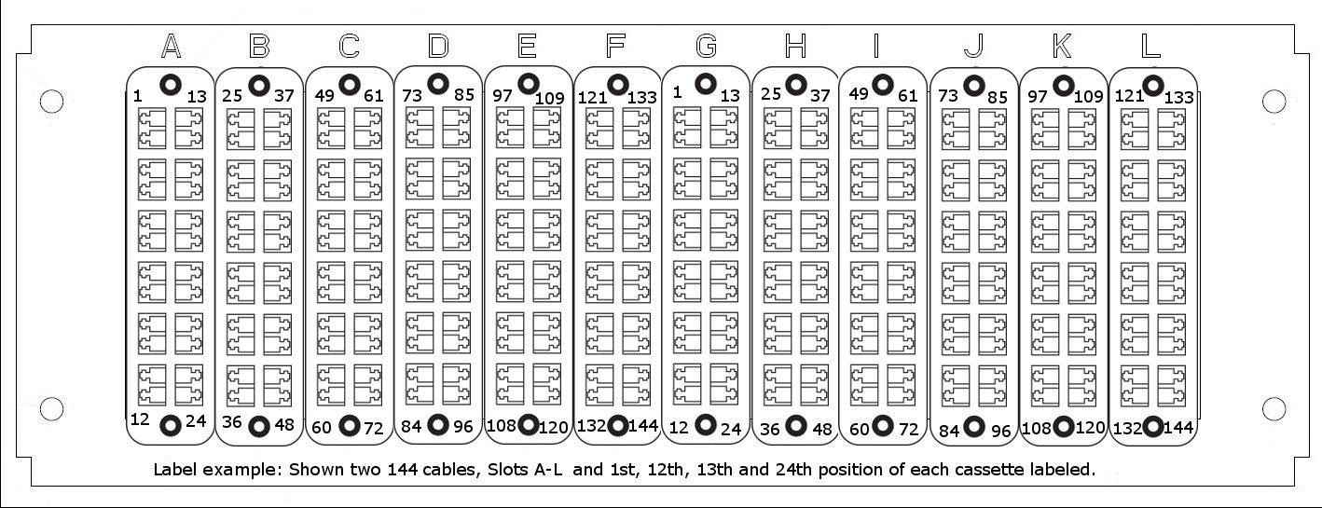

*NIU Design and Construction Standards*

*Division 27 0000 – Communications*

**NIU Campus Cable Standards Appendix A.**

**Revised 3/27/2015**

**27 0553**

**Fiber Distribution Cabinets (FDC) and Wall Enclosure (WIC) labeling examples.**

Communications Div 27 0000 Page 27 of 41

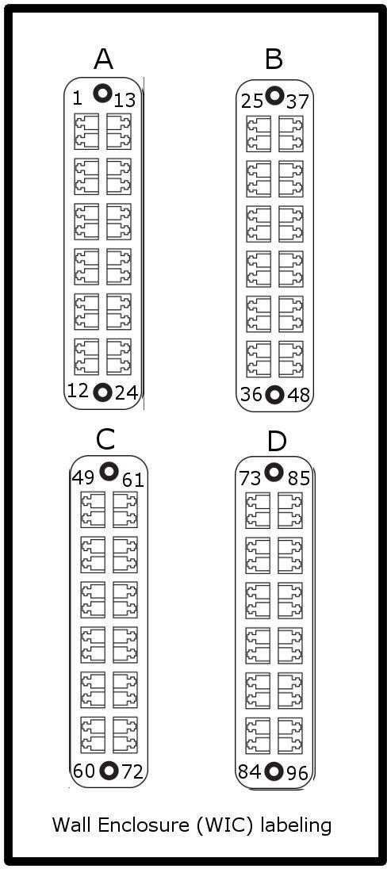

*NIU Design and Construction Standards*

*Division 27 0000 – Communications*

Communications Div 27 0000 Page 28 of 41

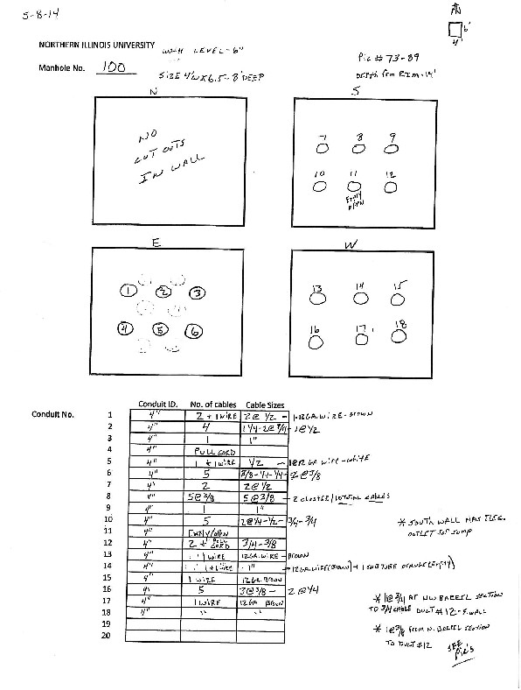

*NIU Design and Construction Standards*

*Division 27 0000 – Communications*

**27 0553**

**Manholes – cable inventory example sheet.**

Communications

Div 27 0000 Page 29 of 41

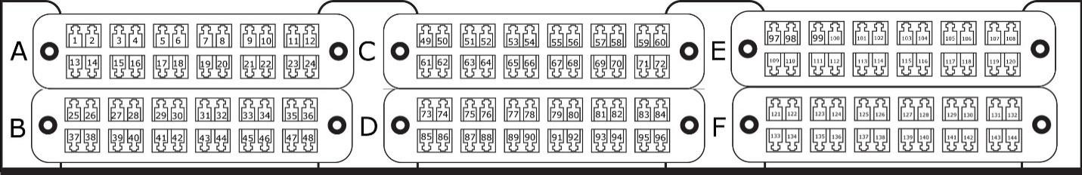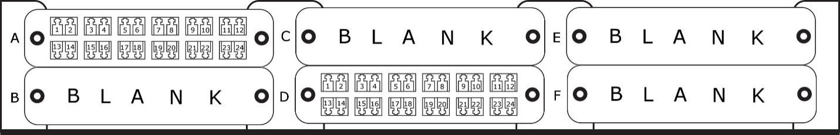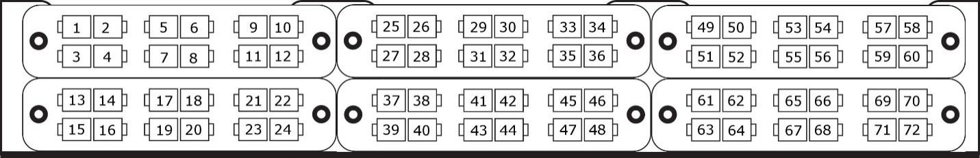

*NIU Design and Construction Standards*

*Division 27 0000 – Communications*

**27 1323 Communications Optical Fiber Splicing and Terminations**

**Examples of fiber counts:**

**1U 19” rack FDC**

**Examples of fiber counts:**

**2U 19” rack FDC**

Communications Div 27 0000 Page 30 of 41

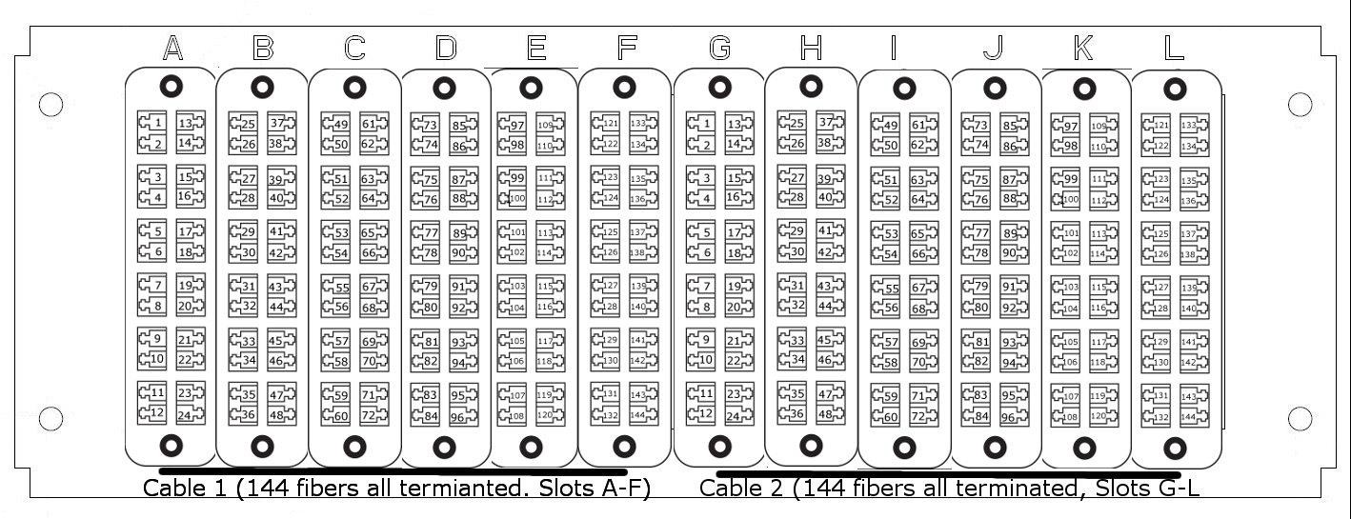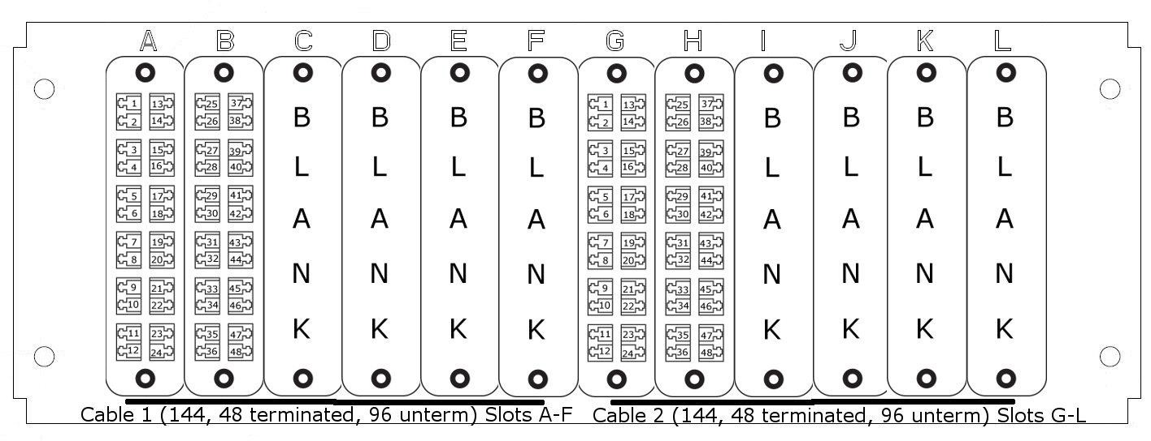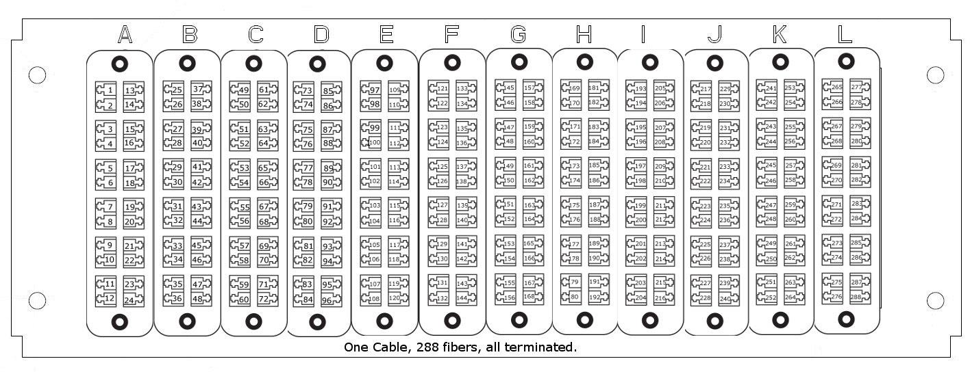

*NIU Design and Construction Standards*

*Division 27 0000 – Communications*

**Examples of fiber counts:**

**4U 19” rack FDC**

Communications Div 27 0000 Page 31 of 41

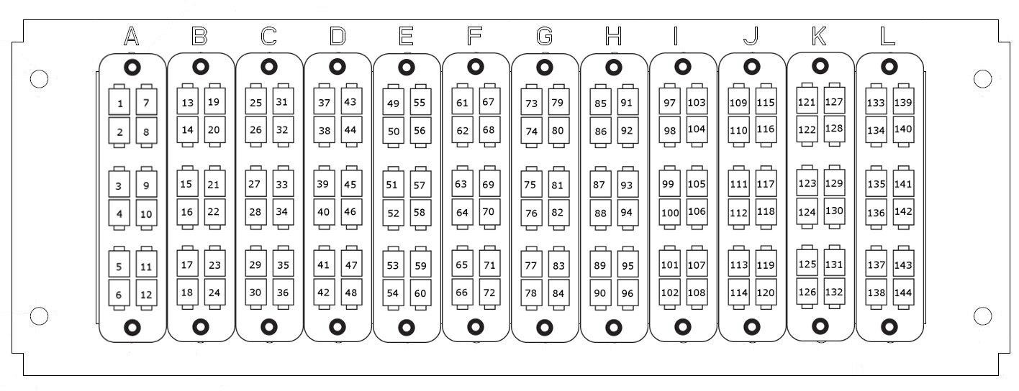

*NIU Design and Construction Standards*

*Division 27 0000 – Communications*

Communications Div 27 0000 Page 32 of 41

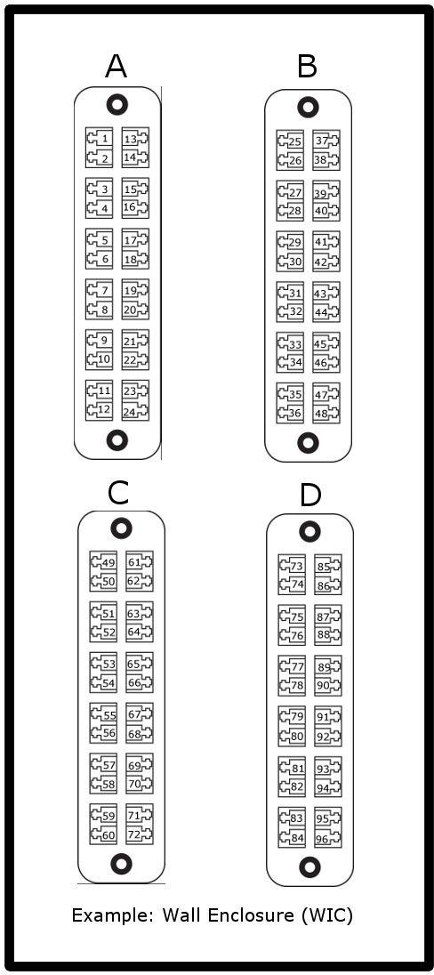

*NIU Design and Construction Standards*

*Division 27 0000 – Communications*

**Examples of fiber counts: Wall Enclosure (WIC) 4 position**

Communications

Div 27 0000 Page 33 of 41

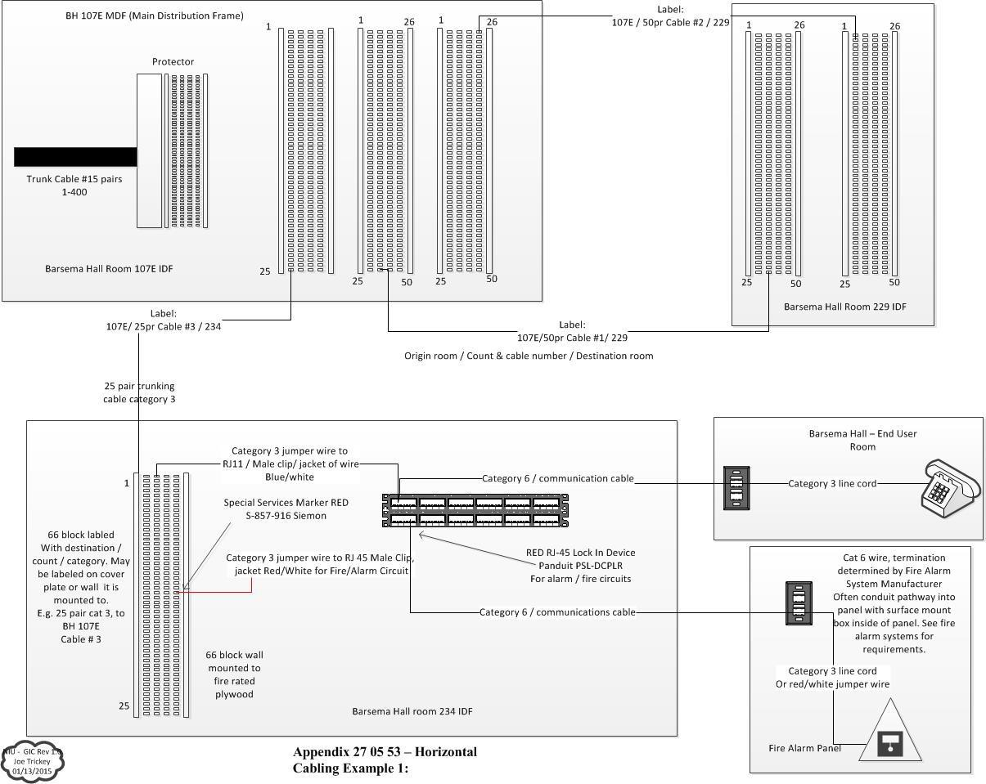

*NIU Design and Construction Standards*

*Division 27 0000 – Communications*

**Example: 27 0553**

**Horizontal Cabling Example**

Communications Div 27 0000 Page 34 of 41

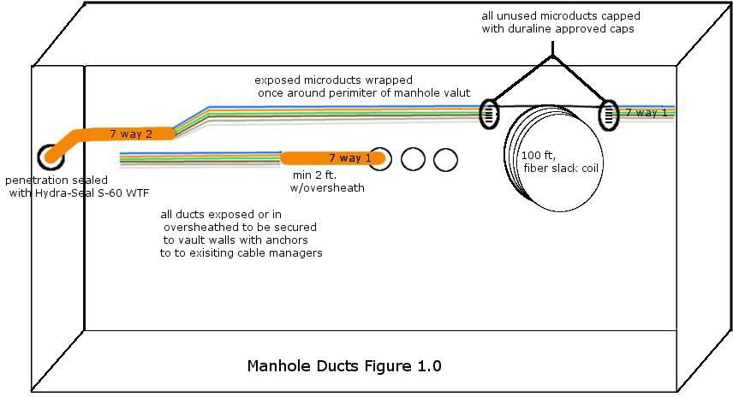

*NIU Design and Construction Standards*

*Division 27 0000 – Communications*

**Example: 27 0543**

**Manhole Duct/fiber installation example**

Communications

Div 27 0000 Page 35 of 41

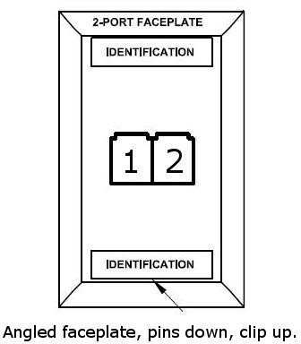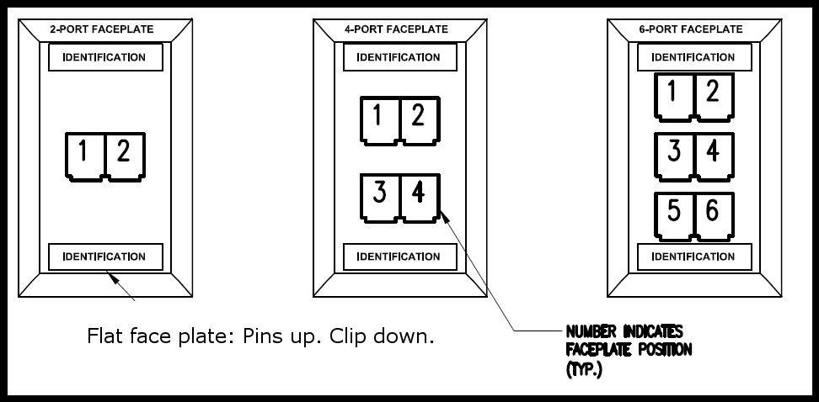

*NIU Design and Construction Standards*

*Division 27 0000 – Communications*

**27 1543**

**Telecommunications Faceplate**

Communications Div 27 0000 Page 36 of 41



*NIU Design and Construction Standards*

*Division 27 0000 – Communications*

**Building Codes Appendix B**

AA AB AD AL AN AS AV BC BH CB CC CF CH CL CO CP CU CV DC DB DD DH DU EB EF EP

FO

Art Annex (2211 Sycamore Road) Visual Arts Building

Adams Hall Altgeld Hall Anderson Hall Art Studio

Barsema Alumni & Visitors Center Broadcast Center (801 N. First) Barsema Hall

Center for Black Studies Child Care Center

Center for Study of Family Violence Chessick Practice Center

Campus Life Building Cole Hall

Chilled Water Plant Credit Union Convocation Center

New Residence Hall Community Center Dorland Building

Douglas Hall Davis Hall DuSable Hall

Engineering Building Evans Field House East Heating Plant

Founders Library

Communications

Div 27 0000 Page 37 of 41



*NIU Design and Construction Standards*

*Division 27 0000 – Communications*

FR FW GA GC GD GH GN GO GR GS HC HE HR HS IA JH LB LC LD LH LT LW MB MC MO MS NC NE NN

NP

Faraday Hall

Faraday West (La Tourette) Gabel Hall

Zeke Giorgi Law Clinic (Rockford) Gilbert Hall

Graham Hall

Grant Towers North Grounds Greenhouse

Grant Towers South Holmes Student Center Hoffman Estates

Human Resource/Printing Services Health Service Center IASBO/Public Admin. Bldg.

Jacobs House (429 Garden)

National Bank and Trust (155 N. Third) Latino Center

Lincoln Hall Lowden Hall Lorado Taft

Wellness & Literacy - Monsanto Red Bldg. Music Building

McMurry Hall Montgomery Hall Motorcycle Safety Neptune Central Neptune East Neptune North

Naperville Education Center

Communications

Div 27 0000 Page 38 of 41



*NIU Design and Construction Standards*

*Division 27 0000 – Communications*

NS NV NV1

NV2

Nursing School

Northern View Community

One Northern View Circle (Community Ctr.) Two Northern View Circle - Apartment Bldg. VA Three Northern View Circle - Apartment Bldg.

VB

Four Northern View Circle - Apartment Bldg. VC Five Northern View Circle - Apartment Bldg. VD Six Northern View Circle - Apartment Bldg. VE Neptune West

Oderkirk Carriage House One Room School House Outdoor Recrecation Center

Parking Garage / Parking Deck

Parking, Durmad House 121 Normal Rd Psychology/Computer Science Bldg.

Physical Plant

President’s House (901 Woodlawn) Univ Police & Pub Safety

Pottinger House (520 College View Crt.) Recreation Center

New Residence Hall East Rockford Educational Center Reavis Hall

Radio Tower Shed

New Residence Hall West Stevens Building

Speech and Hearing Clinic Still Gym

Still Hall

NV3 NV4 NV5 NV6 NW OH OR OS PD PK PM PP PR PS PT RC RE RF RH RT RW SB SC SG

SH

Communications

Div 27 0000

Page 39 of 41



*NIU Design and Construction Standards*

*Division 27 0000 – Communications*

SI SN SP SR SS ST TA TB TD TE TG TH TI TK TL TM TN TO TP TQ TR TB TC TS TV UA UC WH WI

WL

Building Services Stevenson Towers North Swen Parson Hall

Monat, William Bldg. (Social Science Research) Stevenson Towers South

Stadium

Taft - Taft House Taft - Poley House Taft - Pump House Taft – Garage

Taft - Grover House Taft - Arts & Crafts Taft - Sanitation Bldg. Taft - Browne House Taft - Dickerson House Taft - Clarkson House Taft - Dining Hall

Taft - Heckman Dorm Taft - Log Cabin

Taft - Dir. Mobile Home Taft-Water Pressurization Transmitter Building

Taft Campus

Telephone and Security Bldg. Television Center

University Apartments University City (817 W. Lincoln) Watson Hall

Williston Hall

Wellness & Literacy - Monsanto Main Bldg.

Communications Div 27 0000

Page 40 of 41



*NIU Design and Construction Standards*

*Division 27 0000 – Communications*

WP WR WZ YC

ZH

West Heating Plant

Women’s Resources / Arndt House Wirtz Hall

Yordon Center (AAPC)

Zulauf Hall

<http://www.niu.edu/maps/bldgabb.shtml>

End of Division 27 0000

**This section of the NIU Design Requirements establishes minimum requirements only.**

**It should not be used as a complete specification.**

Communications Div 27 0000

Page 41 of 41