

*NIU Design and Construction Standards*

*Division 21 1116 – Facility Fire Hydrants*

June 2013, Draft 00

**21 1116 – Facility Fire Hydrants**

PART 1. - GENERAL

1.01

Scope of Work

A. The Contractor shall furnish all labor, tools, material and equipment necessary to furnish and install new fire hydrants at the locations shown on the project plans or ordered and specified.

B. The Contractor is responsible for all excavation, furnishing and installing the new fire hydrant complete with proper jointing, blocking, backfilling, and all other incidental work necessary to complete this item of work.

1.02

References

A. City of DeKalb Water Main Standard

1. All Facility Fire Hydrant systems installed on Northern Illinois University property shall meet City of DeKalb Water Main Standard

PART 2. - PRODUCTS

2.01

Preferred Manufacturers

A. American Flow Control.-[.www.american-usa.com/products/valves-and-hydrants](http://www.american-usa.com/products/valves-and-hydrants)

1.

5 ¼” Waterous Pacer, WB67-250 (see specification sheet, page 3)

2.

Mueller Super Centurion A423 – 250 (see specification sheet, page 3)

3.

Product substitutions shall meet City of DeKalb Water Main Standard as indicated on specification sheet, page 3

PART 3. - EXECUTION

3.01

All Facility Fire Hydrant systems installed on Northern Illinois University property shall meet City of DeKalb Water Main Standard WM-309

A. Install per manufacturer’s specifications.

B. See specification sheet on page 3 of this document.

Facility Fire Hydrants Div 21 1116 Page 1 of 3

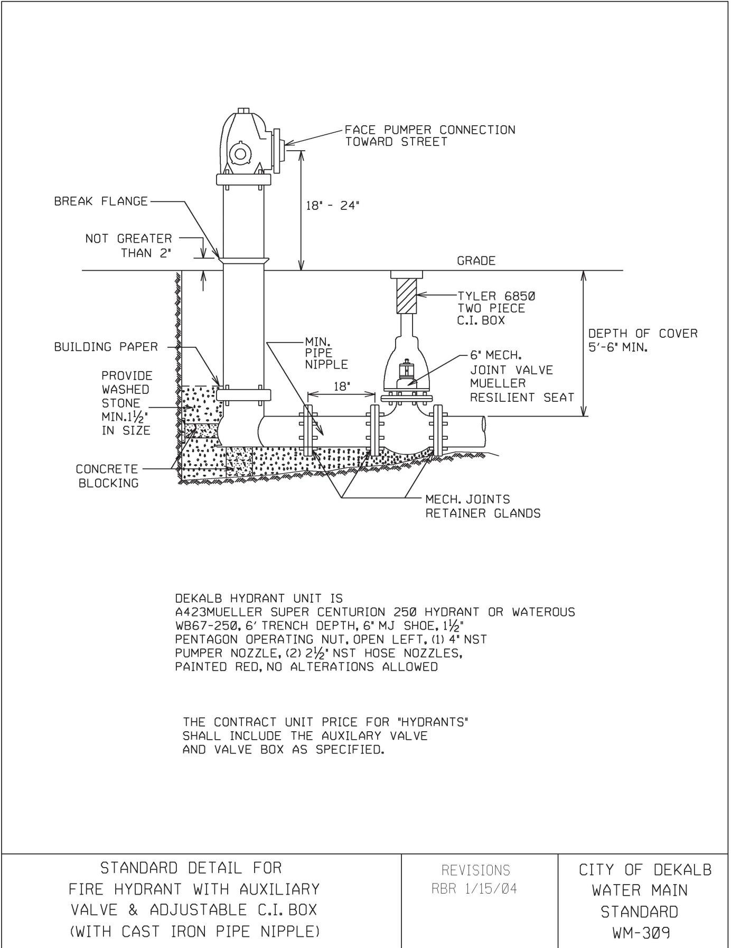

*NIU Design and Construction Standards*

*Division 21 1116 – Facility Fire Hydrants*

Facility Fire Hydrants Div 21 1116 Page 2 of 3



*NIU Design and Construction Standards*

*Division 21 1116 – Facility Fire Hydrants*

End of Division 21 1116

**This section of the NIU Design Requirements establishes minimum requirements only.**

**It should not be used as a complete specification.**

Facility Fire Hydrants Div 21 1116 Page 3 of 3